Directors’ Message on World Metrology Day 2026

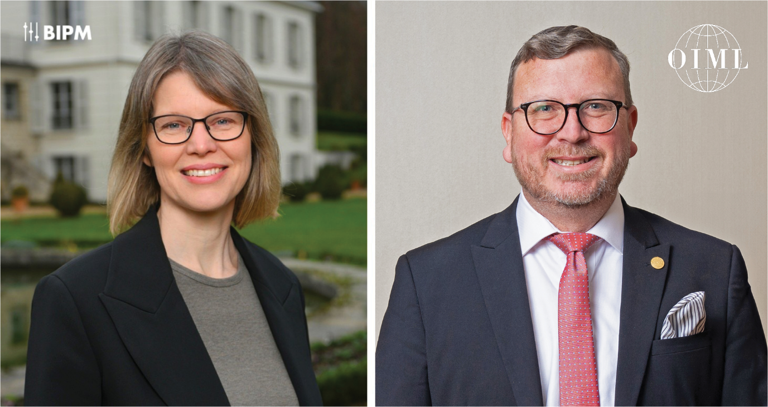

Each year, World Metrology Day offers an opportunity to reflect on the essential role measurement plays in society — and on the cooperation that allows measurements to be trusted, compared and relied upon world-wide.
Following a landmark year celebrating 150 years of the Metre Convention, World Metrology Day 2026 invites us to look forward. This year’s theme, Metrology: building trust in policy making, speaks directly to the relationship between science, governance and public confidence, and to the quiet work that enables decisions to be made with assurance.

Why measurement matters for building trust in policy making
Reliable measurements provide the evidence policymakers depend on when addressing complex challenges — from protecting public health and ensuring safety, to managing energy systems, monitoring the environment and supporting everyday market transactions. When data is accurate, comparable and traceable, decisions can be taken with greater clarity and confidence.
Trust is strengthened further when measurements are not only scientifically sound, but also applied within clear and predictable legal frameworks. Scientific metrology ensures that measurements are accurate and comparable across borders; legal metrology ensures that they are applied consistently and fairly in practice. Together, they help translate policy objectives into practical provisions that serve the public interest.
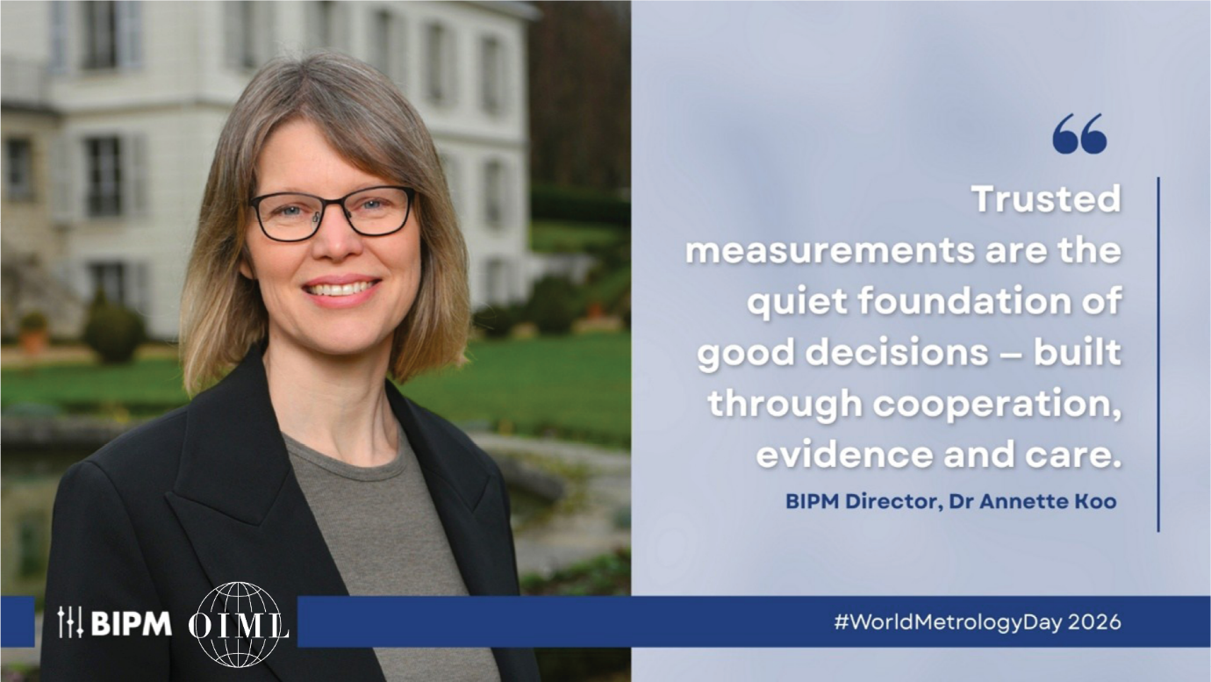

From measurement to policy in practice
The impact of metrology on policy can be seen clearly in areas such as healthcare. During the COVID-19 pandemic, for example, metrology laboratories around the world worked to support reliable measurements for testing, protective equipment and vaccine development. Comparable and traceable data enabled health authorities to assess risks, evaluate performance and act on evidence at a critical moment.
Similarly, long-term environmental monitoring relies on trusted measurements. Internationally comparable measurements of atmospheric gases, water quality and pollutants underpin the data used by authorities to track trends over time and to design policies that protect health and natural resources. Without confidence in how these measurements are made and compared, such decisions would lack a stable foundation.
Metrology also underpins quality assurance and fair market practices. In food safety, for example, metrology programmes have strengthened countries’ ability to measure contaminants, residues and nutritional content, helping authorities and producers demonstrate that products meet agreed specifications.
In parallel, legal metrology frameworks help ensure that measuring instruments used in commerce, such as fuel dispensers, water meters and electricity meters, perform as expected. When instruments are subject to appropriate legal control, trust is strengthened not only between producers and consumers, but also between public authorities and the communities they serve.
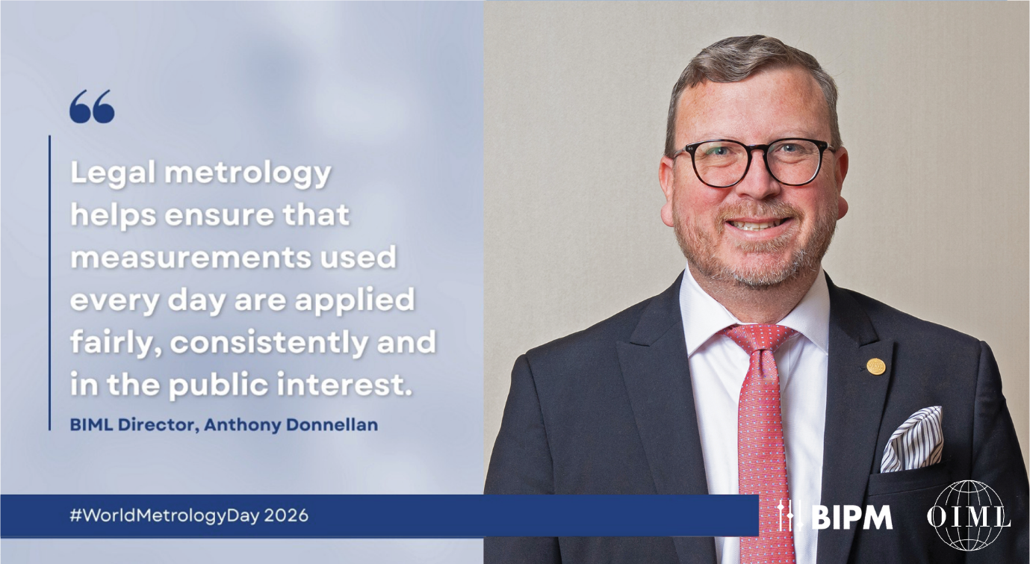

Trust built through cooperation
Ultimately, metrology underpins the evidence that informs policy, the frameworks that protect society, and support economic and social stability. When measurements are reliable and consistently applied, trust extends beyond data — to the institutions, agreements and decisions that rely on them.
This World Metrology Day we invite the global metrology community to reflect on the role trusted measurements play in shaping decisions, and to recognise the cooperation and shared commitment that make this trust possible.
We look forward to celebrating with you all, on 20 May!

Stay Tuned for more…
Further information on events taking place around the world on 20 May — including a webinar organized in collaboration with UNESCO — will be shared in the coming weeks.
Follow us on LinkedIn and keep an eye on our dedicated resource website to be the first to hear about updates,
Share your own plans and photos with us: Email: wmd@worldmetrologyday.org | LinkedIn: @BIPM | @OIML | Hashtag: #WorldMetrologyDay

